Dedication of a Memorial Angel
At the City of London Cemetery
26th April 2009
In Memory of All Children

PUBLIC MEMORIAL ANGEL IN MEMORY OF CHILDREN
OF ALL AGES WHO DEPART BEFORE THEIR TIME

It stands in the City of London Cemetery by the baby garden
It was created with much help & support from Dr. I. Hussain who at the time was the director of the Cemetery & his Colleagues.
After much fund raising by Frances & Mike Speakman, together with family & friends, and helped enormously by The Compassionate Friends who raised so much through our Lunches, Raffles and Donations.

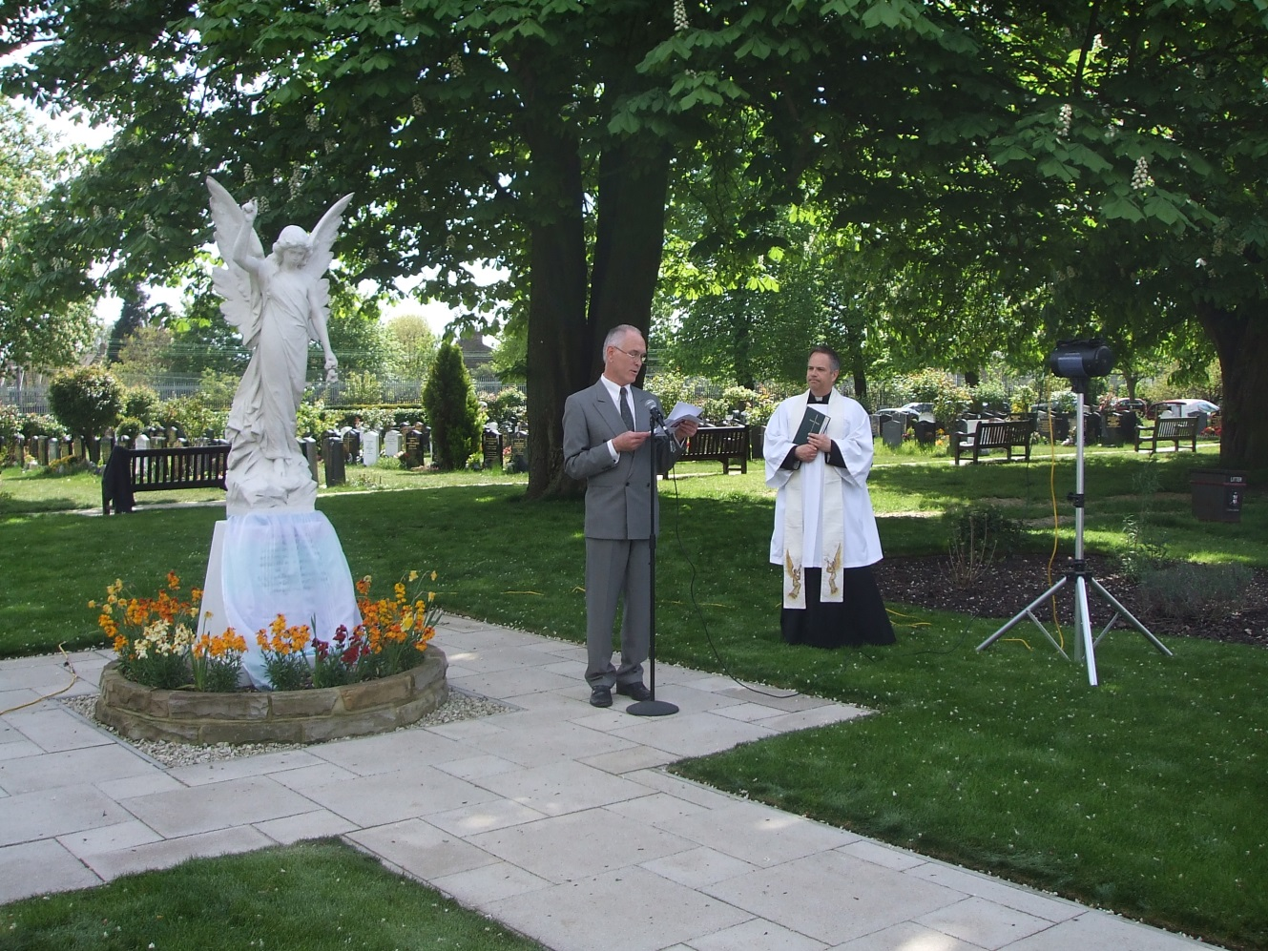

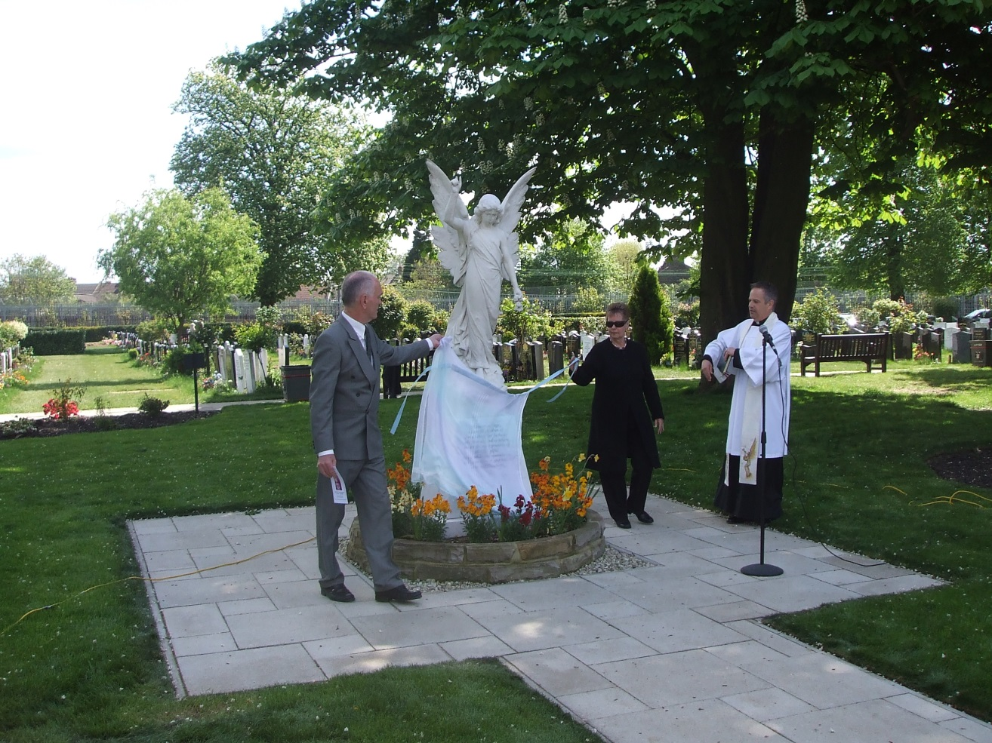

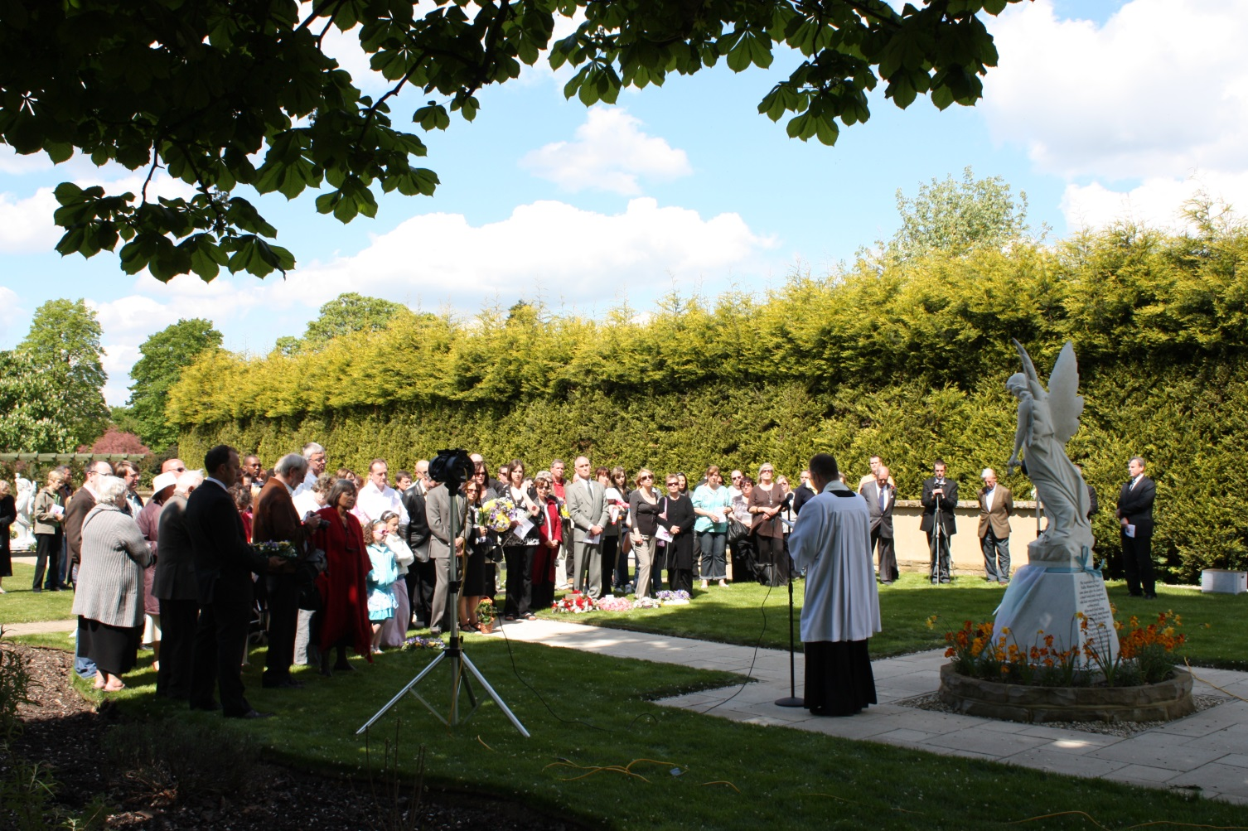

INVITATION

Dedication of Memorial Angel
At the
City of London Cemetery
SUNDAY 26th APRIL 2009 at 1pm.

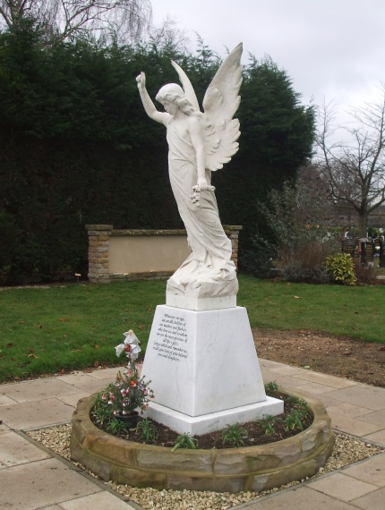

Five years ago, after the death of our much loved grown up daughter Angela, we had the idea for an Angel Memorial. We wanted to create a memorial for all children who have died, for everyone’s sons and daughters everywhere, of whatever age and belief, a focal point for bereaved parents to meet and talk about their precious children. The City Corporation, which is responsible for the cemetery, supported the idea and kindly agreed locate the Memorial Angel in its very well run and secure cemetery. The cemetery management and staff kindly helped and the cemetery's Heritage Advisory Panel made available a beautifully restored Victorian Angel statue for the monument. Following various meetings over the years with the cemetery management, together with our fundraising ventures, wonderfully supported by family and friends from The Compassionate Friends, the Angel Memorial is now sited and ready for the inauguration ceremony on Sunday 26th April 2009.

It is hoped that many will attend the ceremony and that the Memorial, which overlooks the Baby Garden, will bring some comfort to grieving parents with the knowledge that they are not so alone in their sorrow and the memory of their children will always be cherished.

Frances and Michael Speakman

Supported by the City of London Corporation
