**Sedgebrook Hall Hotel**

Chapel Brompton, Northampton NN6 8BD





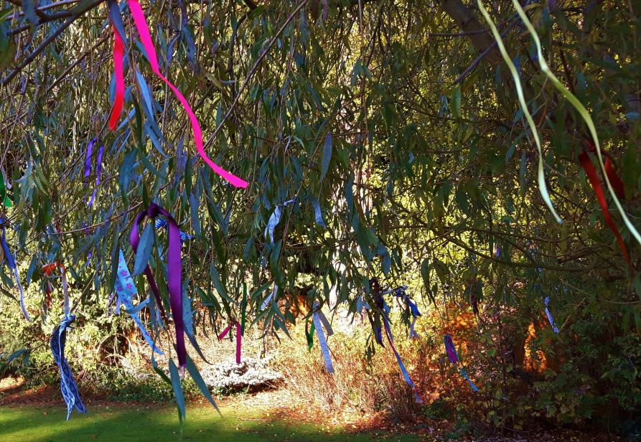

**Walk to Remember**

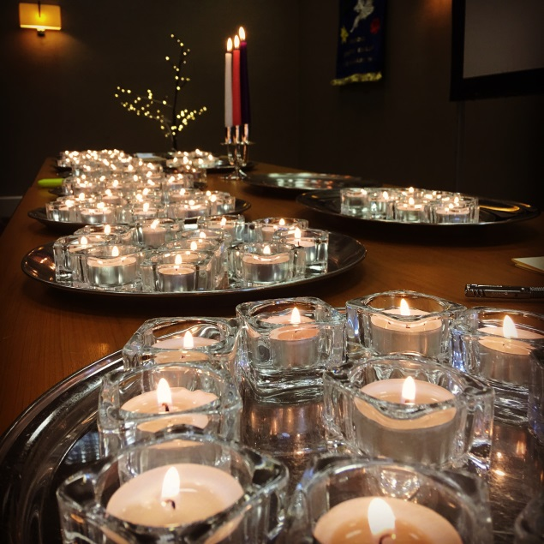

**National UK Gathering 2023**

**for bereaved parents, siblings and grandparents**

**Friday 13 January – Sunday 15 January 2023**

**Memory candles**

**A supportive weekend with others who understand**

**for bereaved parents,**

**siblings and grandparents.**

**Sedgebrook Hall Hotel**

**Person 1:**

**Person 2:**

**Address:**

**Postcode:**

**Email : Tel:**

Please answer the following questions to help us plan the Gathering and tailor our weekend together so that it is right for you.

**Are you a bereaved parent(s)/sibling(s)/grandparent(s)?** (delete as appropriate)

**Room type required**: double/twin/single (indicate as appropriate).

Do you have any **dietary requirements?**

Do you have any **disability requirements?**

*(please note Sedgebrook Hall is not suitable for wheelchair users as there are many stairs and steps)*

Do you have any other requests?

**BOOKING**

**Go online to www.tcf.org.uk/nationalgathering2023**

or complete below

|  |  |  |
| --- | --- | --- |
| **Please indicate as appropriate:** | **Numbers** | **Cost £** |
| **I AM a donating member of TCF** and enclose payment for full board from Friday evening to Sunday afternoon: **£245.00** **per person** |  |  |
| **I am NOT a donating member of TCF** and enclose payment for full board from Friday evening to Sunday afternoon: **£275.00** **per person** (includes one year donating membership of TCF) |  |  |
| **I would like to contribute towards the** **Bursary Fund** for the National Gathering to allow others with limited financial means to attend. |  |  |
| It is also possible to attend the Gathering on Saturday only, Sunday only, or to extend your stay to include Thursday and/or Sunday evenings (B&B only or evening meals as an optional extra. A cost sheet for these additional options is available by emailing or calling us (info@tcf.org.uk or 0345 120 3785). |  |  |
| **TOTAL PAYMENT** |  | £ |

**Your child’s/children’s (or sibling’s) full name(s)**

*(Please note that this is the name we will read out when we are remembering all the children and brothers and sisters during the Candle Lighting).*

**Cause of your child’s/children’s or sibling’s death** (if known and you wish to tell us):

**Their date of death**:

**Age of your child/children or sibling**:

**Do you have surviving children?** YES/NO (delete as applicable)

**Discussion groups** – Is there any particular topic you would like covered in a discussion group?

**If you are a TCF volunteer** would you like to volunteer to help at the Gathering? YES/NO  *If so what sort of things would you like to do? E.g.co-facilitate a group or sharing sessions, offer a craft or other workshop/session etc*



**Book ONLINE at** **www.tcf.org.uk/nationalgathering2023**

Or return this booking form and full payment to:

**The Compassionate Friends, Kilburn Grange, Priory Park Road, London NW6 7UJ**

**I enclose payment of £** ________________ by **cheque** payable to *The Compassionate Friends*

*or*

Or **call us** on **0345 120 3785** to book by debit/credit card over the phone.

Charity No. 1082335

**CANCELLATIONS**

Should you need to cancel your booking, please do so by **1 December 2023** and we will refund your payment. After this date, we are sorry but we are **unable to offer any refunds.**